OtterUI – Ironblight Software, LLC

# Overview

OtterUI is a User Interface Design Tool and Application Programming Interface (API) designed, developed and licensed by Ironblight Software, LLC.

The Otter Editor was developed in C# and runs on Windows PC computers. It features a drag-and-drop interface to create and animate User Interfaces within a graphical and visual interface.

The OtterUI API was developed in C/C++ was designed to be both cross-platform and engine-agnostic, and was accomplished in two ways:

* API was written in C++ with no dependent non-standard 3rd Party libraries
* Platform-specific interfaces (Rendering, File I/O) are implemented by the API user

As a result, new platforms need only be able to run compiled C/C++ code and render triangles in order to leverage OtterUI. Whether the game is written using a custom or proprietary engine, the same authored UI can be used on mixed platforms and mixed engines.

# Features

## Otter Editor

* Processing of TTF fonts, with Unicode (UTF8) and custom glyph font support
* Keyframed animations with timeline control
* Drag-and-Drop visual interface
* Ability to define and export to multiple platforms
* Edit multiple scenes and views simultaneously
* Undo/Redo and history

## OtterUI API

* Cross-platform and Engine-agnostic API
* Unity support through C# Interface and C Plugin DLL
* Control event notification through event handlers
* Unicode (UTF8) string support and conversion routines
* Multiple resolution support through use of anchored keyframes
* Precompiled libraries:
  + iPhone
  + Android
  + Win32

# Screenshots

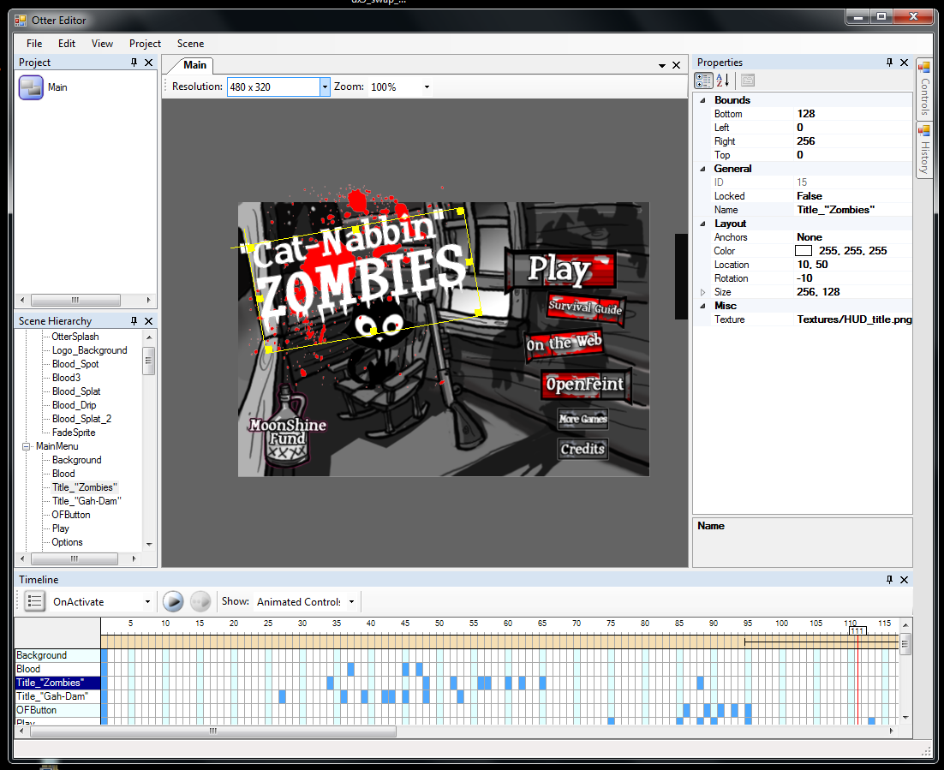

Fig.1 – Otter Editor

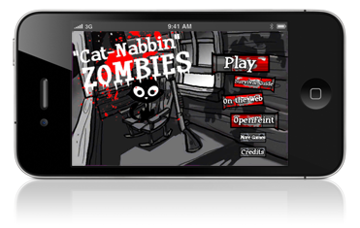

Fig.2 – Authored UI on iPhone 4